学号： 写群里名单的小学号 姓名：

第二章 课后作业

2. 1 Let the stochastic process $\text{ξ}\text{(}\text{t}\text{)}$ be expressed as $\text{ξ}\text{(}\text{t}\text{)}\text{=}\text{2}\text{cos}{\text{(2}\text{πt}\text{+}\text{θ}\text{)}}$
where $\text{θ}$ is a discrete random variable. $\text{P}\text{(}\text{θ}\text{=0)=1}\text{/}\text{2,} \text{P}\left(\text{θ}\text{=}\frac{\text{π}}{\text{2}}\right)\text{=1}\text{/}\text{2}$.
Compute:(1) The mean value ${\text{E}}_{\text{ξ}}\left[\text{ξ}\text{(}\text{1}\text{)}\right]$
(2) The auto-correlation function ${\text{R}}_{\text{ξ}}\text{(}\text{0,1}\text{)}$
--Formula reminder for discrete random variable expectation: $\text{E}\left[\text{X}\text{(}\text{t}\text{)}\right]\text{=}\sum_{\text{i}\text{=1}}^{\text{K}}{{\text{x}}_{\text{i}}}\text{P}\text{(}{\text{x}}_{\text{i}}\text{)}$

2.2: Let ${\text{X}}_{\text{1}}$ and ${\text{X}}_{\text{2}}$ be statistically independent Gaussian-distributed random variables, each with zero mean and variance ${\text{σ}}^{\text{2}}$. Define the Gaussian process
$$\text{X}\text{(}\text{t}\text{)=}{\text{X}}_{\text{1}}\text{cos}{\text{(}}{\text{ω}}_{\text{0}}\text{t}\text{)+}{\text{X}}_{\text{2}}\text{sin}{\text{(}}{\text{ω}}_{\text{0}}\text{t}\text{)}$$
Find the mean value ${\text{μ}}_{\text{X}}\text{(}\text{t}\text{)}$ and auto-correlation function ${\text{R}}_{\text{X}}\text{(}{\text{t}}_{\text{1}}\text{,}{\text{t}}_{\text{2}}\text{)}$.
Given Conditions:
- $\text{E}\text{[}{\text{X}}_{\text{1}}\text{]=0, }\text{E}\text{[}{\text{X}}_{\text{2}}\text{]=0}$
- Variance: $\text{D}\text{(}{\text{X}}_{\text{1}}\text{)=}{\text{σ}}^{\text{2}}\text{, }\text{D}\text{(}{\text{X}}_{\text{2}}\text{)=}{\text{σ}}^{\text{2}}$
- ${\text{X}}_{\text{1}}$ and ${\text{X}}_{\text{2}}$ are independent $\text{⇒}\text{E}\text{[}{\text{X}}_{\text{1}}{\text{X}}_{\text{2}}\text{]=}\text{E}\text{[}{\text{X}}_{\text{1}}\text{]}\text{E}\text{[}{\text{X}}_{\text{2}}\text{]=0}$
- $\text{E}\text{[}{\text{X}}_{\text{1}}^{\text{2}}\text{]=}\text{D}\text{(}{\text{X}}_{\text{1}}\text{)+(}\text{E}\text{[}{\text{X}}_{\text{1}}\text{]}{\text{)}}^{\text{2}}\text{=}{\text{σ}}^{\text{2}}\text{, }\text{E}\text{[}{\text{X}}_{\text{2}}^{\text{2}}\text{]=}{\text{σ}}^{\text{2}}$

2.3: Let $\text{s}\text{(}\text{t}\text{)}$ be a stationary random pulse sequence with power spectral density ${\text{P}}_{\text{s}}\text{(}\text{f}\text{)}$. Find the power spectral density ${\text{P}}_{\text{e}}\text{(}\text{f}\text{)}$ of the modulated signal $\text{e}\text{(}\text{t}\text{)=}\text{s}\text{(}\text{t}\text{)}\text{cos}{{\text{ω}}_{\text{0}}}\text{t}$.

2.4 Let $\text{X}\text{(}\text{t}\text{)}$ be a stationary stochastic process with mean value a and auto correlation function ${\text{R}}_{\text{x}}\text{(}\text{τ}\text{)}$. Its output after passing through a linear system is $\text{Y}\text{(}\text{t}\text{)=}\text{X}\text{(}\text{t}\text{)+}\text{X}\text{(}\text{t}\text{−}\text{T}\text{)}$
(1) Draw the block diagram of this linear system.
(2) Find the auto correlation function and power spectral density of $\text{Y}\text{(}\text{t}\text{)}$.

2.5 A zero-mean Gaussian white noise with power spectral density $\frac{{\text{n}}_{\text{0}}}{\text{2}}$ is fed into an ideal band pass filter. The filter has a center frequency ${\text{f}}_{\text{c}}$ and bandwidth B, as shown in the figure.(1) Find the auto-correlation function of the filter’s output noise.
(2) Write down the one-dimensional probability density function of the output noise.
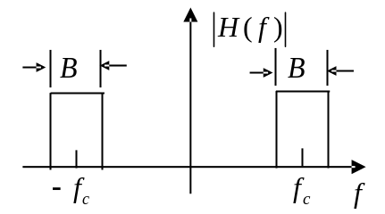

2.6A two-path multi-path channel, the channel transfer function is
$\text{H}\text{(}\text{ω}\text{)=}\text{A}{\text{e}}^{\text{−}\text{jω}{\text{τ}}_{\text{0}}}\left(\text{1+}{\text{e}}^{\text{−}\text{jωτ}}\right)$ The relative time delay between two paths is $\text{τ}\text{=2 }\text{μs}$.
- Find the frequencies where deep fading (nulls零点) happens.
- Calculate the coherence bandwidth of this two-ray channel.
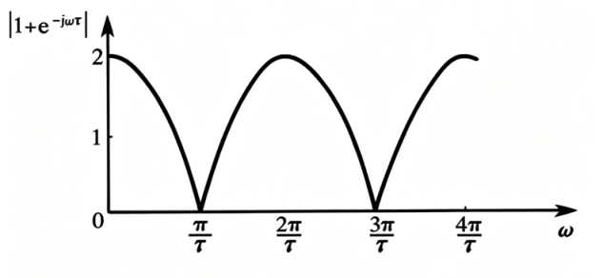

2.7 思考题(从时域和频域两个域进行推导)
